End-User Requirements – EUR-I2302029
  - DBOX SETUP & LAYOUT CHANGE
Quick configurator parent and child layout change

Irpinia Kitchens

Document Approval
Approver | Approved Date | Rejected Date | Comments

Part 1: Functionality Overview
DBOX is required to be a to be a fast data entry for Irpinia’s users or dealers.
  - Parent Defaults. Users will create a new job and then select a room and then select parent default selections (“Style”) as shown below. These options will apply to child items for that room:
  - Parent options:
Note some selections are filtered based on previous selections – this needs to be fast.
There is an upcharge for several parent items – the upcharges are in the attached excel file and depend on the particular value selected.

No | Selection | Description | Upcharge
1 | Room | Text
2 | Style Number | Number | N/A
3 | Series | Dropdown  1700  2000  SC Plus | 0 to -10%
4 | Construction | Dropdown  Flush Channel  Frameless  Recessed Channel | N/A
5 | Channel Type | To Be Provided  Flushed Chanel  Recessed Channel
6 | Door Style | Filtered Dropdown based on Construction. See Excel File Door Style by Construction Tab for Filtering Rules. See Door Style Tab for pricing upcharge. Filtered by Construction Selection
7 | Species | Filtered Dropdown based on Door Style. See DoorStyleBySpeciesbyFinish Tab for the available species in each door style.  Cherry Flat Cut  Engineered Veneer  LPL  Maple Flat Cut  MDF  Oak Flat Cut  Oak Rift Cut  Polyluxe  Pre-Finished Engineered Veneer  Walnut Flat Cut  Walnut Quarter Cut
8 | Colour | Filtered Dropdown based on Door Style and Species. See available colours by species.
9 | Finish | Filtered Dropdown based on Door Style and Species. See DoorStyleBySpeciesbyFinish Tab for the available Finishes in each door style. This will need to be updated.  Gloss-G1  Gloss-G2  Matte-LQ  Matte-NF  Matte-PC  Rustico With Ceruse Zerosheen-LQ  Rustico Zerosheen-LQ  Zerosheen-LQ
11 | Carcase Material | See Carcase Material Tab Dropdown  Champagne Calico  Charcoal Calico  Hardrock  Plywood Natural  Taupe Weave  White Calico
12 | Drawer Type | See Drawer Style Tab  Maple  Oak  Scala Charcoal  Scala Charcoal Crystal  Scala White  Scala White Crystal  Vionaro Charcoal  Vionaro White  Walnut
 |  | Total Upcharge | Sum of above values

There is filtering logic for above fields. As user selects choices subsequent properties are restricted. This is currently done in excel filtering – consider query controlled, excel or hard coding alternatives. Response time here is less critical compared to response time on line items.
The available selections for most of the fields above will depend on the selection from a previous field.

  - Child Items.
DBOX will operate on a “Configure to Price” basis. Sub-second response time when entering mastered items is desirable. If the configurator needs to be accessed then additional response times will be expected. After the transaction is saved the autoprocessor will calculate all BOM information.

The user will then enter Position, Qty and Item No. as shown below:

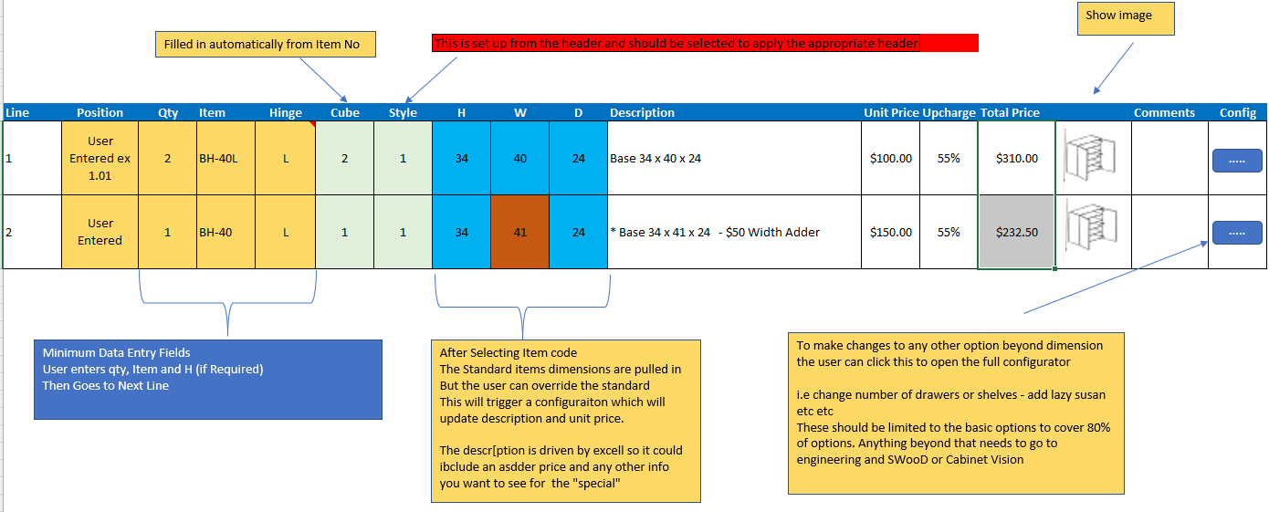

The unit price will be derived form the information in “Cabinet Code with Pricing” worksheet for the mastered item. The upcharge from the parent section will be shown and the total price calculated by:
= unit price * Qty * (1 + Upcharge%)
Note the unit price depends on the a matrix pricing table of the Cabinet Code and Door Price Group

- The user will be able to select a mastered item from the list, example BH-40L. This will automatically fill the columns: Item, Hinge, Cube, Style, H, W, D, unit price, Total price and the image if there is image in the mastered item.
- The field Cube and Style to be pulled from the item master config properties.
- The column “Position” will be empty and editable. The user will add the cabinet position in this field manually.
- Hinge: should be left blank and possibly unavailable if a cabinet is selected where no hinge direction is required (ie bank of drawers)
- The fields H, W and D will default to the mastered item but can be overridden to a custom dimension and an additional charge will apply to line for a custom dimension. These fields will be subject to rules of min and max. If a custom width is entered the logic needs to get the list price of the next widest cabinet as a new starting point for pricing.
- A button that will allow the user to open the full configurator in order to further make selections to properties not displayed on the main grid (i.e. change number of drawers, add a Lazy Susan etc).
Recommendation: Only include the most popular options in the configurator i.e. to cover 90% of orders. The last 10% should be handled as “custom”. This will ensure fast response time and simple configurator maintenance.
2. If there is a custom product that the configurator cannot be used, Irpinia should have a “Custom product” item in the Item master that can be used from their dealers to enter a request for quote/price adding the necessary information for Irpinia to properly quote the Custom order.
3. Image file name will be managed in the workbook.
Q. Will this be submitted in a queue to the Irpinia Engineering department?
Ans. Yes we can setup a workflow so these items are sent to Engineering for processing – design, cost pricing etc.

Accessories
Accessories like Cutlery Divider can be added as 2.1 under associated mastered item or by accessing the configurator. Either way Cutlery Divider needs to be identified as a separate line on the packing slip

Installation
In some cases jobs will have a separate installation charge of 17% of net/list. The users will manually add this as a line time.
Installation PO
Independent contractors are paid a flat price per unit. The bom can include a buy item “Install Unit” wit the Qty determined by the configurator.
Add all contractors as vendors to the “Install Unit” item.
User will be able to create a mat req, select the Vendor and then generate an installation PO

Pricing
Pricing logic is List Price less discount = Net Price. Customers are assigned a discount % level. DBOX should display net price only. Some items (NDI) have 0% discounts
List prices are calculated from a matrix of parent default selections and master item. Irpinia will put all pricing logic in the product line sheet and ensure that config outputs contain all price possibilities:

Seradex to create an automated batch routine to periodically master all items and generate an updated matrix price list. When entering a mastered child item the time to calculate pricing for the line item needs to be less than 2 seconds.

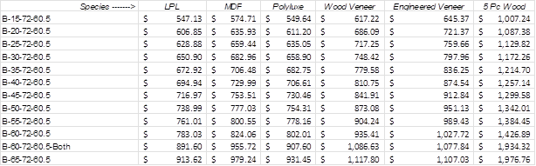

Batch Item Master Function – create function to use autoprocessor to master items in bulk.

Panels/Light Valance/Crown Moulding/Toe Kicks/Other Standard Millwork Items (with a code)
Besides cabinets DBOX needs to be able to handle Panels.
These products may have additional dimensions beyond the W,D and H of cabinets. To enter the additional information the user will click on the line configurator icon and enter the required information. In the case, where a certain dimension(s) is not necessary, that dimension can either be left blank or be made unavailable. For example, a toe kick requires only height and width/length not depth.

To be Supplied by Irpinia
(the support cost for this is not included in above work, however we can assist on a time and material basis)

1)Any creation of new product lines and Excel work for the product lines. Recommended individual product lines for discussion: Base Cabinets, Upper Cabinets, Tall Cabinets – (Cabinet product lines to share a linked workbook for Doors & Drawers) and Panels. This should not be necessary using a code based approach. This is not required for functionality – just a caveat that the larger the excel file the slower the performance when configuring.
2) Modifying exist excel product line files
3) Irpinia will have to master items – i.e. enter all properties on the configurator and then master the combination of properties and image. Mark, I don’t think is realistic to be able to master every sku with every door style, colour, finish, species, carcase material etc. We will need a solution here. We will also keep only 1 image for each style. Agreed,
i.e.
- Configure all properties and dimensions for a BH-40. Select an image and then master an item with the choices as a BH-40. This will also create and store the list price. If you want different prices or discounts for different dealers – let us know and we can explain how to accomplish this.
- Then change the width to 42”, optionally select a new image and then master as item no. BH-42
- Change the width to 44” optionally select a new image and master as item no. BH-44
- And so on – to master all required items.

When a user selects BH-40 in DBOX it will quickly load the mastered item, cube, style and dimensions.
a) If the user overrides a standard dimension the line item will be reconfigured to get a new price and description. This can be reconfigured in the background and the user can meanwhile move on to enter the next line.
b) If the user wants to change other defaults not shown on the line item i.e. change the number of drawers the configurator will launch and the user can override the defaults. This will change the description, bill of material, pricing and image as per configurator logic. The time required for this will depend on how much excel logic, filtered properties etc is required. If you have one large excel file this could take some time.

Note:
All product lines use in a room must include all the same parent input fields.
i.e they must include these fields (see above section for parent input fields):

